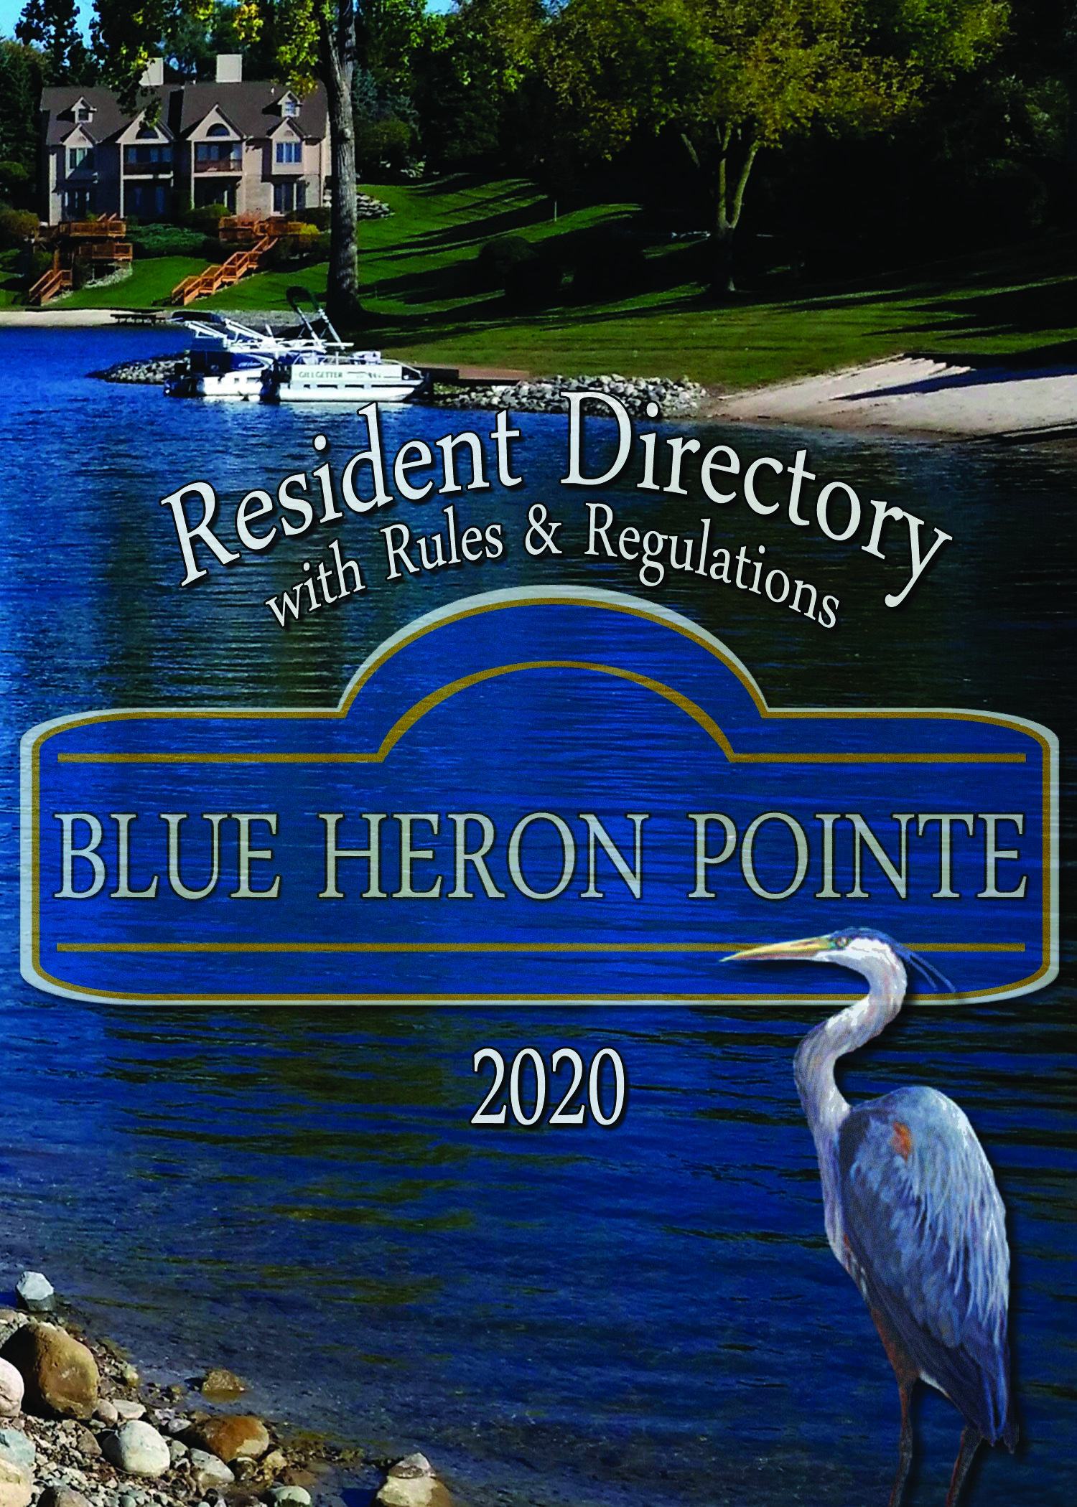
PARTIALLY UPDATED FOR 2022
2022 DIRECTORY COMING SOON

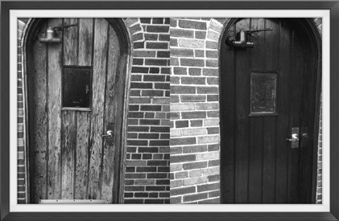
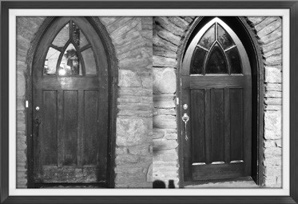
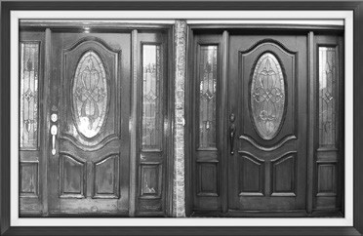
Door Refi nishing & Restoration
Mahogany - Oak
Pine - Fiberglass
doorrenew.com
734-678-7602
john.eggenberger@doorrenew.com
TABLE OF CONTENTS
Blue Heron Pointe Community Information
Rules & Regulations
Residents Listed Alphabetically
Roll by Building/unit Number

DIRECTORY OF ADVERTISERS
Below will be found the names of our business and professional friends, whose interest and support has made this book available to us. We thank them for their support and ask you to consider using their fine products and services.
IFC - Inside Front Cover IBC - Inside Back Cover OBC - Outside Back Cover

Auto Air Conditioning
Davis Auto Care/Tire Center . . . . . . . . . . . . . . . . . . . . . . . . . . . . . . . . . . . . . . . . . . . . . .31 Auto Repair
Davis Auto Care/Tire Center . . . . . . . . . . . . . . . . . . . . . . . . . . . . . . . . . . . . . . . . . . . . . .31 Auto Transmissions
Davis Auto Care/Tire Center . . . . . . . . . . . . . . . . . . . . . . . . . . . . . . . . . . . . . . . . . . . . . .31 Door Refinishing/Restoration
Door Renew . . . . . . . . . . . . . . . . . . . . . . . . . . . . . . . . . . . . . . . . . . . . . . . . . . . . . . . . . . IFC Garage Door Openers
Certified Overhead Door Service. . . . . . . . . . . . . . . . . . . . . . . . . . . . . . . . . . . . . . . . . . IFC Garage Doors
Certified Overhead Door Service. . . . . . . . . . . . . . . . . . . . . . . . . . . . . . . . . . . . . . . . . . IFC Insurance
Michigan Insurance Group. . . . . . . . . . . . . . . . . . . . . . . . . . . . . . . . . . . . . . . . . . . . . . OBC

Cath
Why worry about your personal data being stolen or sold to the highest bidder? Stay secure and private with a printed directory. edral Connecting people to
DIRECTORIES people for over 60 years.
Please visit Cathedral Directories NEW website www.connectingdirectories.com
Directory
Word of Explanation
In this day and age when everything is going digital and being put on the internet, this directory is a safe and secure way to have a personal and complete, alphabetically arranged list of one’s own membership with street address and phone number, without risk of their data being susceptible to online theft. Such a book is of use for many and varied activities throughout the year. When such a convenient volume includes a comprehensive group of advertisements of the merchants and professional people in the community, it serves the dual purpose of a constant reminder of the advertiser’s location and phone number as well as the line of business represented. Thanks to all of the advertisers in this directory for their participation.

BOARD OF DIRECTORS – bhpbod@gmail.com
Joe Zimmer, President  (313) 460-4470  Fred Price, Vice President  (734) 674-9671 | Don Johnson, Vice President (248) 207-6997  Chuck Gaidica, Secretary  (248) 767-0404
Carol Bernardo, Director
(248) 345-0764
Northville Twp. Police Department (non-emergency) (248) 349-9400
Association Website: www.myblueheronpointe.com
Management Company
Office Hours: Monday – Friday 8:30 am to 4:00 pm
Metro Group Management Corporation
2804 Orchard Lake Road, Suite 201 Keego Harbor, MI 48320
Voice/Emergency: (248) 745-7100
Fax: (248) 745-7102
Email: Metrogroup@mgmc.net
J.C. Palmer, MGMC Owner
Renae Bragg, Administrative Manager
Jennifer Krause, Site Coordinator

Blue Heron Pointe Rules and Regulations
Summer 2019 (last revision)
This document has been duly adopted in accordance with the Bylaws to maintain the consistent appearance and the property values of our beautiful community as well as for the enjoyment of our residents. It has been published both in the Resident Directory mailed to all Co-owners, and on our website, www.myblueheronpointe. com. The Bylaws themselves and the Master Deed are recorded in Wayne County, published to all Co-owners at purchase and by mail when amended in 2005, and also on our website. Residents of the Condominium are expected to be k nowledgeable of both the Bylaws and the Rules and Regulations. Fines have been established for non-conformance to both.

Current Fine Schedule
First offense $50 All fines after second offense will be at the $100 rate.
Second offense $100 Fines for the same offense can be issued every 30 days.

I . Condominium Unit Ownership, Maintenance and Modification
- Exterior modifications, including paint/stain colors and window/door replacement, are not permitted without approval from the Board of Directors. A $500 cash bond must be posted with the Management Company when requesting exterior modifications to a Unit. These funds will be used if your project is not completed within the approved design specifications but will be promptly returned when the project is completed satisfactorily. Refer to Bylaws, Article VI, Section 2 for further restrictions.
- Detailed “Specifications for Window and Doorwall Repair/Replacement” have been published as an addendum to these Rules. Co-owners are responsible for compliance with these specifications. A copy may be obtained from the Board of Directors, from the Management Company, or from www.myblueheronpointe.
com.
- Exterior Maintenance
  - The Association is responsible for repainting and / or re-staining those portions of the balcony previously painted or stained. Repainting will only be completed if the current balcony paint color matches our current exterior paint color. Re-staining will be completed using our current association stain color.
This work will be done only when the unit is painted during our regular painting schedule (units are repainted every 4 years) and only if required. Decks, Stairways or Landings are excluded from this activity. See the exception in Paragraph 2. below.
  - In between Association-conducted painting events, Co-owners are responsible for any staining or painting of the Balcony, including floors, spindles, and rails required to maintain aesthetics. Color and surface character must be consistent with present stain or paint unless approved by the Board in writing. The approved colors are posted on our website and also available by calling the Management Company. PLEASE NOTE: Any change in material or color is considered a Modification, subject to the Rules above.
  - Co-owners are responsible for repair and maintenance of the concrete Front Porch Cap, all Patios, and including staining of the Front Door, and staining or painting if previously approved of the Decks, Stairways and Landings appurtenant to their Unit.
- If you lease out your condominium Unit, it is your responsibility as Co-owner to draft your lease agreement in accordance with Bylaws, Article VI, Section 2. Furthermore, the Co-owner shall furnish a copy of the Bylaws and the Rules and Regulations to the lessee and remind them that they must abide by the same. The Co-owner is responsible for all fines, penalties, assessments and other fees. Privilege to use the Common Areas is extended to Lessees at the pleasure of the Association and may be revoked at any time by the Board.
- Satellite dishes are a permitted Modification. The intended location, size and mounting must be approved by the Board of Directors in writing prior to the installation.
- Basketball backboards may not be attached to the building. See Restricted Activities section for use of portable sporting equipment. G. Nothing is to be hung from the gutters.
- Hot tubs are not permitted at Blue Heron Pointe.
- Window air conditioning units are not permitted.
II. Grills, Outdoor Furniture and Equipment (See www.myblueheronpointe.com for fire term definitions.)
- Open Burning, including fires in fire pits and gas fired heaters, is not permitted.
- Co-owners with a deck made of wood or other combustible material shall take extra care to avoid a fire emergency from outdoor cooking accidents. The Northville Township Fire Department may classify Blue Heron Condominiums as “Multi-Family Dwellings”, and has issued guidelines for use of Charcoal Briquet, Electric and LP-gas (Propane) cooking devices. A Co-owner who allows such a grill to be located on such a deck will be presumed to be using it at that location.
- In any case, such grills shall not be LOCATED OR USED on or under a balcony, nor may they be located or used near wood stairs, porch, garage, or shrubbery.
- Natural gas grills must pass inspection by the Township before use. It is highly advisable to seek advice from the Township before installing such devices.
- Propane tanks, empty or not, shall not be stored or used indoors or in your garage.
- As stated in the Bylaws, “no furniture or equipment of any kind shall be stored thereon [on any patio or porch] during seasons when such areas are not reasonably in use.” Decks, patios and surrounding grounds are to be cleared of all furniture, flower pots, free-standing decorative and other items, except grills, for the “Winter Season”, defined as from November 30th until April 1st. Outside furniture only may be kept on the balcony level during the “Winter Season” as long as it is not stacked or crowded into the space. Neutral furniture coverings (Tans or Browns that closely match our balconies in coloring) are allowed on balcony furniture. All other hanging or standing equipment and decorative items normally kept on deck, patio or surrounding grounds shall be stored in the dwelling, garage or offsite. The central air conditioning units may be covered neatly for the winter season.
- Only furniture and equipment consistent with normal usage of the Common Elements are permitted. Stacking of furniture or equipment is not permitted at any time.

III. Decorations, Exterior Lighting and Plantings
- The American flag, the State flag and team flags or pennants are the only flags permitted to be displayed at all times. No other decorative or symbolic flags or pennants may be displayed at any time. Also see Signage section.
- Statues, artwork, ornamental figurines, or similar items are limited to a total of three (3) total in each on the porch (floor, wall and posts), balcony, patio/deck, beach and in each of the following locations: separate garden area of the Unit on the Common Elements. Decorating the dock, lawn, driveways, trees or shrubs with such items is not permitted.
- Ornamental flowerpots, however, are permitted to sit on porches, driveways, decks, and balcony railings, or on the driveway adjacent to garage doors. However, they must be removed from porches and driveways during the winter season to eliminate risk of damage from snow plowing.
Flower pots or baskets may be hung only from the balcony, porch ceiling, roof soffits, and tree branches. No artificial flowers are permitted at Blue Heron outside the Unit.
- Annuals, shrubs, bulbs and perennials may be planted in the Common Elements around your Unit at Co-owners expense. Co-owners are responsible for maintaining them. Annuals shall be removed no later than November 30th. The Association and its contractors are not responsible for inadvertent loss or damage to same.
- Other than holiday decoration and single day events, auxiliary lighting is permitted adjacent to the Unit only for purpose of augmenting the illumination of walking areas and stairs. The Association and its contractors are not responsible for inadvertent loss or damage to same.
  - Ground level lighting shall be low voltage. New fixtures shall have no interconnecting wires.
  - Locations permitted are the mulched beds beside the front walk, the upper edge of the beach, and the perimeter of lakeside decking.
  - Locations not permitted include trees, shrubs and lawn. Height shall be limited to 18” above the walking surface.
  - Lighting affixed to the Unit is considered a Modification (See Section I-A.). F. Holiday decorations
  - Christmas and Chanukah decorations may be displayed from Thanksgiving through January 10 only.
  - Decorations respecting other national holidays may be displayed from 7 days before until 7 days after the holiday.
  - Holiday decorations for any individual unit shall be limited to the following:
    - Strings or nets of low wattage bulbs (10 watts or less) arranged on the trees and or shrubs and to the architectural elements of the building except the gutters.
    - Flood lighting with a single bulb illuminating the front door.
G. Fireworks of any kind and type are prohibited at Blue Heron Pointe.

IV. Signage
- Generally, free standing signs are not permitted outside the unit, whether for commercial, personal security or ornamental purposes. If you wish to advertise the sale of your Unit on site, with or without the use of a realtor, you are required to obtain a standard “Home Available” sign, and optionally a brochure box stand, from the Management Company for a small fee. A contact phone number of your choice may be placed on the sign. No other signs or postings will be permitted at Blue Heron referencing the Unit being for sale.
- Small stickers from your home security system provider are the only signs permitted in any windows. Advertising or other signage is not permitted outside the unit nor in windows, including signs of companies doing work in your Unit, even during a job.
- For Sale signs are not permitted on personal items such as cars, bikes, etc

V. Pets
- Refer to the Bylaws for allowable presence of animals on the premises. Co-owners shall register animals to be kept on the premises by breed, gender and name. Animals other than dogs and cats require written Board approval. The Board may approve a maximum of two (2) pets per unit.
- Co-Owners shall assure that pets are held on a leash and accompanied by a responsible adult when outside. Co-owners shall not leave pets tethered outside unattended.
- Co-owners are required to clean up after their pets.
- When walking pets with retractable leads, it is not permitted to walk them within 25 feet of any other Units including garages without permission.
- Co-owners shall not permit pets on the beach or grass areas near the Pointe Gazebo.
- Co-owners are financially responsible for damage to lawns, shrubs, buildings, etc. caused by their pets and those of their Lessees.

VI. Trash Collection
- Pickup of trash is normally scheduled for Tuesday morning each week. Certain holidays move collection one day later.(New Years Day, Memorial Day, Independence Day, Labor Day, Thanksgiving Day, Christmas Day) Recycling pickup is provided on every other Tuesday.
- Trash containers shall not be placed outside any earlier than 6 PM the evening prior to pick up and must be returned to your garage no later than dusk the day of pickup. Containers shall be lined with a tied trash bag, covered by a secure lid to preclude animal and wind disturbance, and placed at curbside on a paved area.
- Tied trash bags not in containers may only be left outside the morning of scheduled pickup.

VII. Water, Beaches and Docks
- Refer to IX. Restricted Activities, Paragraph A for authorized use of these facilities.
- Children under 12 shall wear a life jacket while boating or in the water.
- Co-owners are responsible for preventing materials being dumped into street drains or field drains in lawn areas, as the water from these drains feeds our lake. Co-owners’ should keep in mind that contractors such as painters, carpet cleaners, cement workers, etc. may not be aware of this rule unless you inform them.
- Boats
  - One paddle boat, pontoon boat or sail boat is permitted per unit. These boats shall be no wider than 7 feet 7 inches, and no longer than 14 feet 7 inches overall when measured above the waterline, including any motor in the down position. Be aware that boats are often marketed with nominal dimensions that may be several inches less than or greater than actuals. Names such as “714”, suggesting 7 feet wide by 14 feet long may belie actual dimensions much greater than that. Above all, keep in mind that boats longer than 12 feet were not envisioned when the beaches and docks were built, so consider your neighbor’s water access needs for boating and swimming when obtaining a new boat.
  - All boat motors shall be electric and 3 horsepower or less. Only one motor per unit is permitted. Maximum speed for any boat is 5 MPH. (Bylaws Section 15, Article VI).
  - Personal watercraft in the form of one (1) canoe, up to two (2) stand-up paddle boards, or up to two (2) kayaks per unit are permitted. These boats shall not exceed 17 feet in length.
  - All boats shall be marked with the unit number on the stern. Suitable numerals are available from the management company.
  - A “no wake” rule is in effect at all times for boats within 50 feet of residential shore line.
  - All water craft shall be removed from the lake from November 30th until April 1st. They shall be kept in a garage or stored off site.
  - Boating is not permitted in the Wetlands except as authorized by the Board.
- Docks
  - Docks are shared between units and boats and watercraft for any single coowner must not take more than 50% of the docking area closest to their unit.
  - Any request for handrailing on the docks to ease entry and exit from watercraft must be approved by the board and meet the American Disabilities Act access requirements.
- Fishing and Waterfowl
  - Blue Heron Pointe complies with a catch and release fishing program. Exceptions are bluegill less than 6 inches and all pike.
  - Fishing is not permitted in the Wetlands.
  - Waterfowl are not to be fed under any circumstances.

VIII. Motor Vehicles and Parking
- Vehicles shall not be parked or driven with any wheels on the grass at any time.
- Co-owners and Lessees’ vehicles shall be parked in the garage or on the driveway. Garage doors shall be closed except when being used or unless slightly opened for ventilation.
- Unless stored within the garage with the door closed, the following vehicles are not permitted to be parked at Blue Heron Pointe except as noted in the following paragraphs:
  - Commercial vehicles
  - Boats
  - Trailers
  - Camping vehicles and trailers
  - Motorcycles
  - ATV’s
  - Snowmobiles/jet skis
- House trailers and RV’s may be parked for a single overnight stay in a co-owners driveway for loading and unloading of camping supplies. The aforementioned vehicles are not permitted to be parked overnight on our streets. Stays of more than 1 consecutive night must be approved by the Board and will be subject to additional fees of $75 per day.
- Co-owners are not permitted to use visitor parking areas overnight except when their driveways are being repaired or plowed by the Association, and with Board written permission, during remodeling.
- Guests should use designated visitor parking or Co-owner driveways.
- Fire codes prohibit overnight parking on the streets in Blue Heron Pointe.
- Inoperative vehicles of any type may not be stored anywhere outside of a unit.

IX. Restricted Activities
- Blue Heron Pointe Lake and the Pointe Beach including the adjacent grass areas, the Gazebo, the shoreline, the Overlook and the Boardwalk are Common Elements; ie, Private Property restricted in use to the Members of the Association, their families and accompanied guests. “No Trespassing” signs, posted on the property, will be honored by Township Police. The Association shall provide two BHPCA Identity Cards and two matching Keychain Tags to the Co-owner’s household to be carried by the Co-owner or registered Lessee when using any of these Common Elements. Adult children of Members may be unaccompanied if they bring the BHPCA Identity Card or Keychain Tag. This card is not to be given to contractors or other persons, including guests of the household. Minors shall be accompanied by a Member of the Association when using any of these Common Elements.
- Minors under 16 shall be accompanied by adult residents after 9 pm.
- Skate boards, scooters and rollerblades shall not be used on the bridge over the Wetlands. Bicycles may be used with care.
- Driving golf balls on Common Elements is not permitted.
- Portable basketball backboards may be used where and when annoyance from noise and likelihood of damage to buildings or personal property is low. Such equipment must be stored at the end of the day and when not in use. Permanent backboards are not permitted (See Section I).
- At the end of each day, chairs, mats, toys, etc. shall be removed from the beaches and docks.
- To use the Gazebo and/or surrounding deck at the Pointe for a special event, the Co-owner shall contact the Management Company who keeps the schedule. Co-owners wishing to erect a tent for a special event shall submit a request and receive written approval from the Management Company. In both instances a security deposit is required to be submitted to the Management Company before the event. The requesting Co-owner shall attend the event and be responsible for it.
- Garage sales are not permitted except as scheduled by the Association. Co-owners may request written permission to hold an estate sale by contacting the Management Company. Co-owners are required to leave a $500 deposit before holding an estate sale to cover any incidental lawn or building damage. I. Laundry activities are not permitted outside the unit.
- Noise carries over the water; for that reason, music or other loud noises are to be taken inside after 10 pm. If you notice trespassers at any time or disturbing noises coming from a unit call Northville Township Police at (248) 349-9400.
- The noise from outside construction work using power tools, such as circular saws, impact drivers and heavy equipment, may be considered “disturbing the peace” if conducted after 10pm and before 8am and shall not be permitted. Neighborly consideration should be given before authorizing any such activities on Sundays and National Holidays.
Observations of possible infractions may be reported to the management company by Co-owners in writing, signed with name and address. They may also be reported by the Management Company or Board members without impunity. Confidentiality of the reporter’s identity will be respected. If an infraction of these rules has occurred, the Management will send a letter to the Co-owner requesting that the violation be corrected. Failure to correct same may result in escalating fines and late fees as described in the Bylaws.

Residents

–A–
Arnold, Eric & Susan His: 586-246-4837 Her: 248-217-0644
18165 Blue Heron Pointe, Unit: 63, Bldg: 16 rarnold@miltimorecom; suarnint@aolcom
Ayres, Nick & Carolyn 248-773-7287
18285 Blue Heron Pointe, Unit: 55, Bldg: 14

–B–
Banaszak, Griff & Carol 248-349-6326
18164 Blue Heron Pointe, Unit: 38, Bldg: 10 His: 734-216-2836 Her: 734-216-2817 carolbanaszak@yahoocom
Barriger, Brian & Ruth 248-347-4199 18044 Blue Heron Drive W, Unit: 79, Bldg: 20
Beger, Gary & Gayle 248-348-3895 47415 Blue Heron Court, Unit: 129, Bldg: 33 Berent, Melvyn & Barbara 248-773-5204 18160 Blue Heron Pointe, Unit: 37, Bldg: 10
Bernardo, John & Carol 248-345-0764 18315 Blue Heron Pointe, Unit: 49, Bldg: 13
Blain, Jeannie 248-762-2034
18048 Blue Heron Drive W, Unit: 78, Bldg: 20
jeanniecb@comcastnet

Boksha, Myron & Nanette His: 248-207-8141 Her: 313-701-2229
47704 Blue Heron Drive S, Unit: 75, Bldg: 19 myrond248@gmailcom; nanette248@gmailcom

Bomzer, David & Diane His: 610-659-2691 Her: 484-437-1387
18214 Blue Heron Drive W, Unit: 96, Bldg: 24
d4bomz@gmailcom; DBomz23@gmailcom
Bosanko, Willard & Virginia 248-349-8694 47595 Blue Heron Court, Unit: 138, Bldg: 36 Bremenkampf, Gordon L 248-347-2421
18304 Blue Heron Pointe, Unit: 46, Bldg: 12 gordbrem@umichedu
Brundage, Dianne 248-347-4818
18269 Blue Heron Pointe, Unit: 58, Bldg: 15
bakidee25@gmailcom

Buckle, Edward & Colleen His: 586-214-1925 Her: 248-345-8147
18061 Blue Heron Pointe, Unit: 68, Bldg: 17
metroewb@aolcom; colleenb1@hotmailcom

Buckley, Dan & Bev His: 248-568-1231 Her: 248-763-1750
18312 Blue Heron Pointe, Unit: 48, Bldg: 12 danbevbuckley@comcastnet
Bukowski, Ron & Nancy 248-374-0881
18190 Blue Heron Drive W, Unit: 89, Bldg: 23 His: 248-880-5840 Her: 248-880-2401 bukowskisr@gmailcom

–C– Carosio, Mike & Charlotte His: 248-444-6854; Her: 734-776-1617
18262 Blue Heron Drive W, Unit: 100, Bldg: 25
mikecarosio@ameritechnet;jacunskicharlotte@gmailcom
Carpenter, Arlen & Sharon 248-349-2024
18172 Blue Heron Pointe, Unit: 40, Bldg: 10 arcrsc@gmailcom
Carpenter, Kenneth & Carol 248-348-4942 18500 Blue Heron Drive W, Unit: 120, Bldg: 30
Cazal, Dr Anibal & Heidi 248-380-1555 18289 Blue Heron Pointe, Unit: 54, Bldg: 14
Cheney, Terry & Donna 248-255-5107 18479 Blue Heron Drive, Unit: 1, Bldg: 1
Collins, Thomas & Coleen 586-855-0016 18408 Blue Heron Drive W, Unit: 114, Bldg: 29
Cruz, Victor 313-574-4558
18297 Blue Heron Drive E, Unit: 14, Bldg: 4

–D–
Darish, Betty Jane 248-347-6541
18381 Blue Heron Drive, Unit: 8, Bldg: 2
248-345-9395
PSHDAR@msncom
Daugherty, David & Karen 248-773-7348
18090 Blue Heron Drive W, Unit: 85, Bldg: 22 His: 313-268-0299 Her: 313-300-1189 ddaugh3646@gmailcom; hairlink@aolcom
D’Avanzo, Joseph & Patricia 248-348-1366
47573 Blue Heron Court, Unit: 137, Bldg: 36 His: 313-600-9759 Her: 248-207-1173 golfmom51@comcastnet
Delgaudio, Sidney & Regina 248-347-7859
18353 Blue Heron Drive, Unit: 10, Bldg: 3 His: 248-790-0111 Her: 248-790-2969 sidney_delgaudio@comcastnet; reginagaudio@comcastnet
Dudley, Gary & Lanette 248-344-0150
18314 Blue Heron Drive W, Unit: 103, Bldg: 26

–E–
Evans, Arlene 248-449-7302
18409 Blue Heron Drive, Unit: 6, Bldg: 2

–F–
Farhat, David & Karen His: 313-938-0398 Her: 248-207-0268
18339 Blue Heron Drive E, Unit: 11, Bldg: 3
DLFCSI@AOLcom; Karenfarhat@comcastnet
Fernandez, Rodrigo & Evelyn 248-380-6063
18203 Blue Heron Drive W, Unit: 128, Bldg: 32A
His: 248-982-7509 Her: 248-982-1879
RPFERNAND@COMCASTNET; EBFERNAND@COMCASTNET
Fillar, Joe & Michele 248-924-3596
47494 Blue Heron Drive S, Unit: 27, Bldg: 7 His: 248-912-2934 Her: 734-718-3499 jefillar@yahoocom; mgfillar@yahoocom
Finkel, Carol 248-596-9164
18265 Blue Heron Pointe, Unit: 59, Bldg: 15
SDFCDF1@gmailcom

Flanagan, Mike & Anna His:517-749-2193 Her: 517-214-0068
18104 Blue Heron Pointe, Unit: 34, Bldg: 9 flanaganm49@gmailcom; flanagananna7@gmailcom
Flynn, Lynn 734-748-0892 18210 Blue Heron Drive W, Unit: 95, Bldg: 24
Forcellini, Antonio 248-770-9604
18281 Blue Heron Pointe, Unit: 56, Bldg: 14 t4leisure@aolcom

Friedman, Len & Meredith His: 248-986-0291 Her: 248-420-4503
18012 Blue Heron Pointe, Unit: 32, Bldg: 8 lmfriedman@wowwaycom; friedman4852@gmailcom
Fuhrman, John & Ellen 248-449-7421
18261 Blue Heron Pointe, Unit: 60, Bldg: 15
His: 313-400-5728 Her: 313-460-0663 jfuhrman02@gmailcom; ejfuhrman@gmailcom

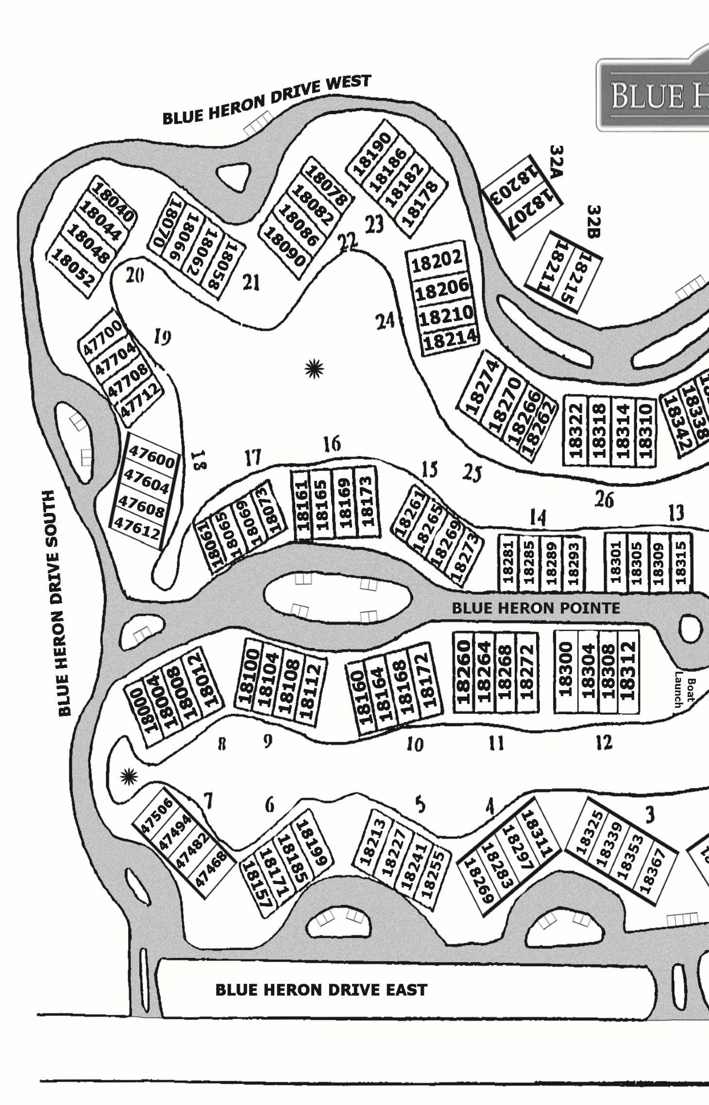
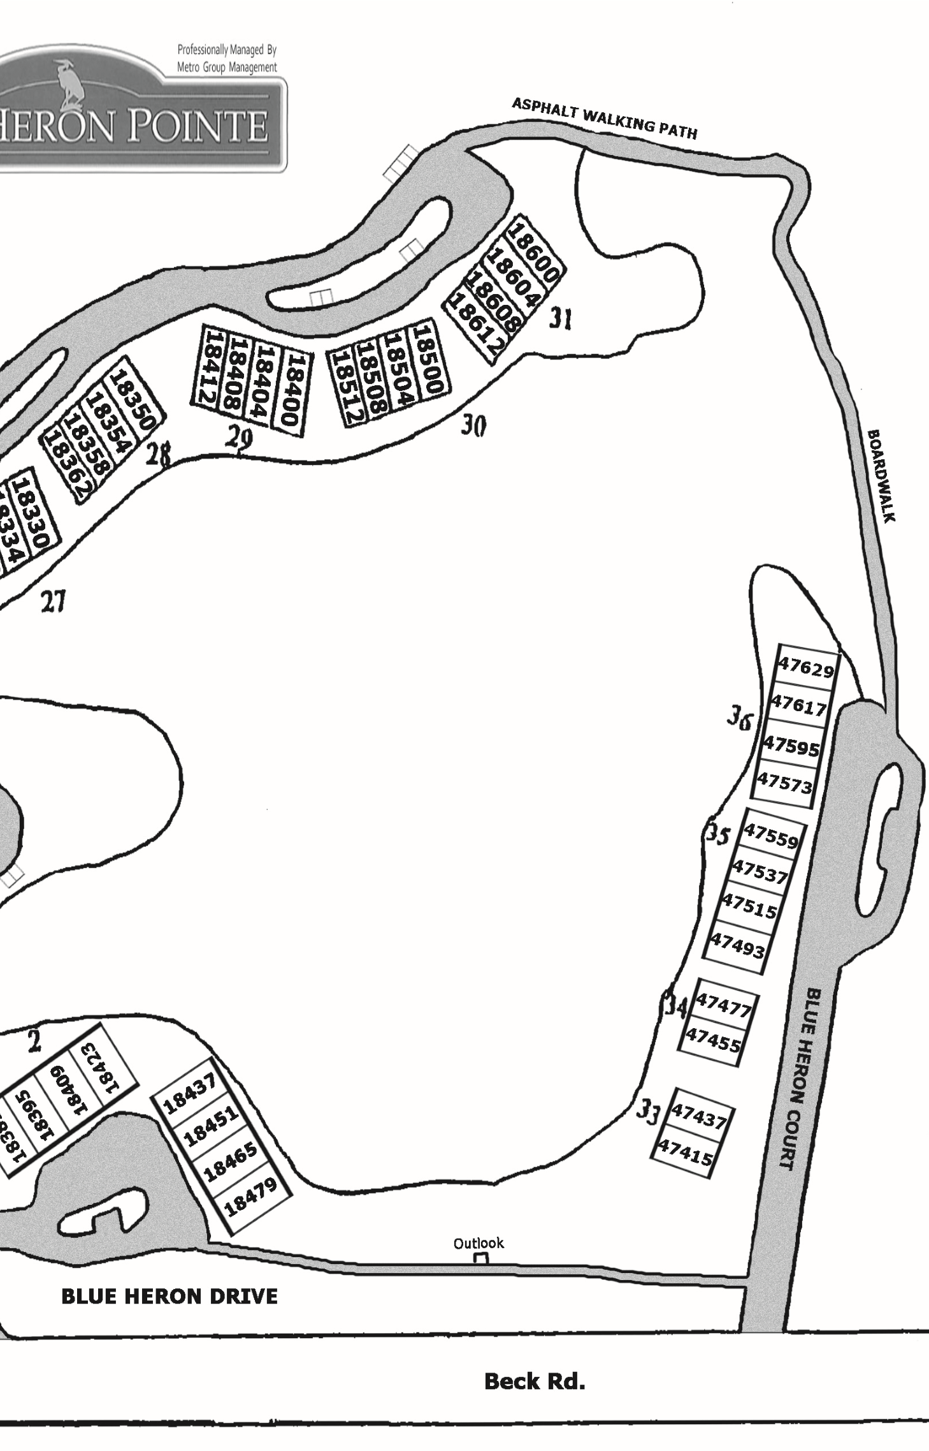

–G–
Gaidica, Chuck & Susan 248-924-2122
18078 Blue Heron Drive W, Unit: 88, Bldg: 22 His: 248-767-0404 Her: 248-767-7452 cgaidica@comcastnet; sgaidica@comcastnet
Gantchar, John & Annmarie 248-344-0037
47537 Blue Heron Court, Unit: 135, Bldg: 35 His: 248-895-5276 Her: 248-345-8321 jmg0426@comcastnet; moocho@comcastnet
Gaudet, Jerry & Bonnie 734-637-3829
18213 Blue Heron Drive E, Unit: 20, Bldg: 5 Jgaudet809@aolcom
George, Gary 248-640-9157
47617 Blue Heron Court, Unit: 139, Bldg: 36
CHESSGCG@YAHOOCOM
Girvan, Richard & Sharon 248-380-6389 47608 Blue Heron Drive S, Unit: 70, Bldg: 18
Gordon, Kathleen 248-722-9056
18300 Blue Heron Pointe, Unit: 45, Bldg: 12 kgordon@blue-chipus
Gorecki, Ms Sandra 248-821-3691
- Blue Heron Pointe, Unit: 67, Bldg: 17 sandygorecki@gmailcom
Gottleber, Don & Linda 248-344-4471
- Blue Heron Drive W, Unit: 82, Bldg: 21 His: 248-880-9554 Her: 248-207-5860 bothgotts@aolcom
Gould, Jonathan & Deborah 248-347-4181 18062 Blue Heron Drive W, Unit: 83, Bldg: 21
Grant, Chuck 248-808-1700
18260 Blue Heron Pointe, Unit: 41, Bldg: 11 cbgrant44@gmailcom
Grant, Steven 313-595-9413
18241 Blue Heron Drive E, Unit: 18, Bldg: 5

–H–
Hammerick, Ralph & Kathleen 248-374-1384
18270 Blue Heron Drive W, Unit: 98, Bldg: 25
Her:248-974-9695 kathhammer@sbcglobalnet

Haskin, Dale & Jacqueline 248-449-5021
18608 Blue Heron Drive W, Unit: 122, Bldg: 31 dhaskin1@gmailcom; jmhaskin1@gmailcom
Hathaway, Dale & Alice 248-449-1359 18604 Blue Heron Drive W, Unit: 123, Bldg: 31
Hayat-Tarrar, Imran & Neha 929-841-6409
18268 Blue Heron Pointe, Unit: 43, Bldg: 11 tarar_88@hotmailcom
Hecker, Mike & Jane 248-672-8413
18293 Blue Heron Pointe, Unit: 53, Bldg: 14
734-276-6160
Hill, Daniel & Margaret His:732-856-4006 Her: 704-340-5215
18227 Blue Heron Drive E, Unit: 19, Bldg: 5 dmhill59@yahoocom; mahill61@yahoocom
Hubert, Urban & Mary 248-347-0663
18330 Blue Heron Drive W, Unit: 108, Bldg: 27
Winter: 727-344-3655

–J–
Jakubowski, Philip & Linda 734-667-5253 18367 Blue Heron Drive, Unit: 9, Bldg: 3
Jary, Mike & Maura Her: 248-345-6638 His: 248-928-6848
18350 Blue Heron Drive W, Unit: 112, Bldg: 28 maurajary@yahoocom; mjary@intevaproductscom
Jeannotte, Lorraine (Lori)
18404 Blue Heron Drive W, Unit: 115, Bldg: 29
Jensen, Gerrie 248-449-8240
18322 Blue Heron Drive W, Unit: 101, Bldg: 26
248-981-7900 gerriepugh@yahoocom
Jiskra, Jon & Gail His: 586-206-6667 Her: 248-752-5850
18255 Blue Heron Drive E, Unit: 17, Bldg: 5 jajiskra@gmailcom; gailjiskra@gmailcom

Johnson, Don & Diane His: 248- 207-6997 Her: 248-345-2142
47712 Blue Heron Drive S, Unit: 73, Bldg: 19 nosnhojnod@aolcom; dajohnson782@aolcom
Judd, Leon & Mary Ellen 248-348-7196
47612 Blue Heron Drive S, Unit: 69, Bldg: 18

–K–
Kaiser, Betty 248-347-3779
47468 Blue Heron Drive S, Unit: 25, Bldg: 7
Kawaelde, Ann 248-380-9671 47477 Blue Heron Court, Unit: 132, Bldg: 34
Kidd, Lynette 734-453-7565 18266 Blue Heron Drive W, Unit: 99, Bldg: 25
Kimble, Mary 248-308-3824
18301 Blue Heron Pointe, Unit: 52, Bldg: 13 kimblemarry@gmailcom
King, Stephen & Ann His: 734-776-3151 Her: 734-347-1235
18058 Blue Heron Drive W, Unit: 84, Bldg: 21
swk49140@gmailcom; annmarykay@sbcglobalnet
Kornmesser, Marilyn 248-347-4747
18451 Blue Heron Drive, Unit: 3, Bldg: 1 kornmesser1821@comcastnet
Kunkel, Ken & Pauline 248-349-3999
18423 Blue Heron Drive, Unit: 5, Bldg: 2
His: 248-921-9344 Her: 248-921-2676 Kenkunkel@aolcom; knpkunkel@aolcom

–L–
Lapham, Charles 248-349-3466 18412 Blue Heron Drive W, Unit: 113, Bldg: 29 LaRue, Christopher & Patricia 248-380-8594
18342 Blue Heron Drive W, Unit: 105, Bldg: 27 His: 734-464-2480 Her: 248-420-7073 chrislarue@wowwaycom; patmclanelarue@wowwaycom
Lefler, Joseph & Carol 248-347-6552 47700 Blue Heron Drive S, Unit: 76, Bldg: 19
Light, Holly Anne 734-751-5158
18206 Blue Heron Drive W, Unit: 94, Bldg: 24 lightholly@hotmailcom
Linson, Donald 386-314-5394
18334 Blue Heron Drive W, Unit: 107, Bldg: 27
dlinson2003@yahoocom
Lorigan, Daniel & Nancy 248-349-0202
18199 Blue Heron Drive E, Unit: 21, Bldg: 6 His: 586-382-3000 Her: 248-231-5290
danlorigan@comcastnet; nancylorigan@comcastnet

–M– Manning, Terrance & Pamela His: 586-915-4199 Her: 248-761-7429
18273 Blue Heron Pointe, Unit: 57, Bldg: 15 tjm@tmainvestmentscom; pttmamanning@msncom Mansouri, Joseph & Roya His: 248-912-5179 Her:248-884-8476 18112 Blue Heron Pointe, Unit: 36, Bldg: 9
Maxwell, Joyce 248-348-5211
18358 Blue Heron Drive W, Unit: 110, Bldg: 28
248-444-8560 trujoyce@aolcom
Mayes, Elizabeth 248-380-6690 18211 Blue Heron Drive W, Unit: 126, Bldg: 32B
McGowan, Mary 248-347-0730
47506 Blue Heron Drive S, Unit: 28, Bldg: 7
248-891-7807
mmm41891@aolcom
Mehta, Virendra & Suzanne 248-348-3132 47493 Blue Heron Court, Unit: 133, Bldg: 35 Milbrandt, Carlton & Dyonne 248-842-4867
18272 Blue Heron Pointe, Unit: 44, Bldg: 11 carlton@milbrandtscom; dyonne@milbrandtscom
Miller, Cynthia 231-233-4460
18185 Blue Heron Drive E, Unit: 22, Bldg: 6
CYNTHIALMILLER100@gmailcom
Mills, Nick & Amy His: 313-530-0780 Her:313-268-4366
18318 Blue Heron Drive W, Unit: 102, Bldg: 26
nmills111@gmailcom; amymills@aoncom
Mitchell, Paul & Patricia 248-347-7706
18073 Blue Heron Pointe, Unit: 65, Bldg: 17 Her:248- 982-2869 His: 248-921-1727 patriciajmitchell@comcastnet
Morley, Mark & Kathy 248-344-9442
47629 Blue Heron Court, Unit: 140, Bldg: 36 His: 248-514-9822 Her: 248-207-6420 mmorleys@comcastnet
Mowinski, Josephine 248-347-7848
18354 Blue Heron Drive W, Unit: 111, Bldg: 28
248-821-3020 jomo0113@gmailcom
Murphy, Katherine 248-938-4993
47708 Blue Heron Drive S, Unit: 74, Bldg: 19
734-666-8713 blackjag1944@comcastnet Murphy, Tom & Marilynn 248-349-8133
18215 Blue Heron Drive W, Unit: 125, Bldg: 32B His: 248-882-8133
tmurphy1@wideopenwestcom

–N–
Nelson, Mark & Jay Ann 248-596-0025
18173 Blue Heron Pointe, Unit: 61, Bldg: 16 His: 313-460-5735 Her: 734-502-2873 markandjay@comcastnet; nelsonm@butzelcom
Norris, Deanna 248-773-5320 18052 Blue Heron Drive W, Unit: 77, Bldg: 20
Nowakowski, Robert 313-407-3924
18437 Blue Heron Drive E, Unit: 4, Bldg: 1
RMN@TECHNOSPORTSCOM

–O–
Oneda, Flavia 734-748-4058
18008 Blue Heron Pointe, Unit: 31, Bldg: 8 flaviah@hotmailcom
Orlyk, John & Joanne 248-735-8304
18178 Blue Heron Drive W, Unit: 92, Bldg: 23

–P–
Pedersen, Rita 248-348-6198 18157 Blue Heron Drive E, Unit: 24, Bldg: 6 Pender, Jerome & Pamela 304-296-4736
18168 Blue Heron Pointe, Unit: 39, Bldg: 10 His: 703-937-7102 Her: 703-991-3349 jerry@pendersworldcom; pam@pendersworldcom
Perrault, Ernie 248-349-8122
18207 Blue Heron Drive W, Unit: 127, Bldg: 32A
248-320-3844 ernestineperrault@sbcglobalnet
Peterson, Jeffrey & Janice 248-305-9721 18040 Blue Heron Drive W, Unit: 80, Bldg: 20 Preston, John (Bud) & Gail 248-380-0691
18182 Blue Heron Drive W, Unit: 91, Bldg: 23
Her:248-464-2221 His :248-376-1440
budpreston@comcastnet; gailpreston@comcastnet
Price, Fred & Kathleen 248-449-6392
18171 Blue Heron Drive E, Unit: 23, Bldg: 6 His: 734-674-9671 Her: 734-658-8961 kprice1957@gmailcom; fprice504@comcastnet

–R–
Rauner, Allen & Sharon 248-773-5401 47600 Blue Heron Drive S, Unit: 72, Bldg: 18 Richardson, Albert & Marva 313-999-7225 18338 Blue Heron Drive W, Unit: 106, Bldg: 27
Rivard, Daniel & Eleanor 248-735-8766 47437 Blue Heron Court, Unit: 130, Bldg: 33
Rivard, Larry & Diane 313-670-5196
47515 Blue Heron Court, Unit: 134, Bldg: 35 dlr0107@yahoocom
Roth, Kenneth (Mike) 248-207-3993
18504 Blue Heron Drive W, Unit: 119, Bldg: 30 mikeroth88@comcastnet

–S–
Samson, Jeanette 248-349-9023
18161 Blue Heron Pointe, Unit: 64, Bldg: 16
248-921-3990

Sargent, Michael & Kate His: 734-639-0723 Her: 734-502-7502
18400 Blue Heron Drive W, Unit: 116, Bldg: 29 mmm2sargent@gmailcom; KatherineEichenberg@yahoocom
Schiff, Steven & Nadine 734-353-7547
18508 Blue Heron Drive W, Unit: 118, Bldg: 30 Shschiff524@gmailcom
Schmehl, David & Sharon 248-312-7266
18325 Blue Heron Drive, Unit: 12, Bldg: 3 His: 313-580-2785 Her: 248-930-4546 deschmehl@msncom; sharonschmehl@yahoocom
Scott, Richard 248-380-8453
47559 Blue Heron Court, Unit: 136, Bldg: 35
313-319-6422 rls@dickscottcom
Seeley, Fred & Lyn 248-374-2205 18465 Blue Heron Drive, Unit: 2, Bldg: 1
Serowiecki, Daniel & Jeanette 630-627-6286
18269 Blue Heron Drive E, Unit: 16, Bldg: 4 Both:630-913-6286 Jackie: 248-921-1284 Serwatowski, Janet 248-347-2743 18512 Blue Heron Drive W, Unit: 117, Bldg: 30
Sheehy, Josephine 248-344-4681
18169 Blue Heron Pointe, Unit: 62, Bldg: 16
248-974-6832 josiesheehy@comcastnet Ten: Anne Sheehy
Sinelli, Iris 248-348-9229
18612 Blue Heron Drive W, Unit: 121, Bldg: 31
248-921-0529 irissinelli@gmailcom
Smith, Christopher & Tina His:248-939-1003; Her: 248-930-0197
18274 Blue Heron Drive W, Unit: 97, Bldg: 25
csmith51163@gmailcom;tmsmith1263@gmailcom
Spaven, John & Dorothy 248-735-8373
18395 Blue Heron Drive, Unit: 7, Bldg: 2 His: 248- 767-7302 Her: 248-767-7301 letmestunt@yahoocom; dorothyspaven@yahoocom
Speck, Gary & Sherry His:734-635-3046 Her: 734-635-3057
47604 Blue Heron Drive S, Unit: 71, Bldg: 18 c51419@yahoocom; sherryspck@yahoocom
Steckel, James 850-866-7214 18283 Blue Heron Drive E, Unit: 15, Bldg: 4
Stevens, Norma 248-924-3587
18202 Blue Heron Drive W, Unit: 93, Bldg: 24
734-260-3432 nstev99457@aolcom
Stewart, Jeffrey 248-374-8556
18086 Blue Heron Drive W, Unit: 86, Bldg: 22
His: 313-418-7966 Burnhamgroup@yahoocom

–T–
Tegtmeyer, Louis 734-674-6261
18309 Blue Heron Pointe, Unit: 50, Bldg: 13 ltegtmeyer@msncom
Townsend, Jim & Beth 734-536-2959
18362 Blue Heron Drive W, Unit: 109, Bldg: 28 jandbtownsend@attnet
Trice, Sharon
18264 Blue Heron Pointe, Unit: 42, Bldg: 11
Turomsha, Michael & Maureen 248-349-8040
18082 Blue Heron Drive W, Unit: 87, Bldg: 22
Her: 248-345-9813 His: 248-345-9817
michael@turomshacom; maureen@turomshacom

–V–
Valentini, Alicia 734-748-9337
18004 Blue Heron Pointe, Unit: 30, Bldg: 8

–W–
Weaver, Bill & June 248-344-8743
47455 Blue Heron Court, Unit: 131, Bldg: 34
wweav1@comcastnet; Juneeweave@mecom
Whitehead, Alan & Jill 248-342-4507 18186 Blue Heron Drive W, Unit: 90, Bldg: 23
Wilkinson, Rollo & Marilyn 248-380-7903
18000 Blue Heron Pointe, Unit: 29, Bldg: 8
His: 248-231-0996; Her: 248-231-0994
RGwilkinson@wowwaycom
Willard, Sandra 248-347-0766 18600 Blue Heron Drive W, Unit: 124, Bldg: 31
Williams, Patrick
18308 Blue Heron Pointe, Unit: 47, Bldg: 12
Wright, Kenneth R 734-502-1563
18108 Blue Heron Pointe, Unit: 35, Bldg: 9
KRWCNC@HOTMAILCOM
Wright, Pete & Sue 248-348-4496
18305 Blue Heron Pointe, Unit: 51, Bldg: 13 His: 313-720-6915 pstkwright@comcastnet

–Y–
Young, Gregory & Sandra 248-380-5944
18311 Blue Heron Drive E, Unit: 13, Bldg: 4 Her:248-721-1574 gjydds@gmailcom; sandrayoung0223@gmailcom
Young, Michael & Karen 248-374-1316
18070 Blue Heron Drive W, Unit: 81, Bldg: 21 Her: 248-761-9050 His: 248-506-5465 mikeyoung317@gmailcom; kyoung@autometalcom

Yuhasz, Bob & Rosanne His: 248-982-4906 Her: 248-982-4907
18310 Blue Heron Drive W, Unit: 104, Bldg: 26
nev55@aolcom

–Z–
Zhao, May 586-604-3172
18069 Blue Heron Pointe, Unit: 66, Bldg: 17 may_zhao@hotmailcom

Zimmer, Paul (Joe) & Lisa His: 313-460-4470 Her: 313-706-5655
18100 Blue Heron Pointe, Unit: 33, Bldg: 9 jzimm11@gmailcom; lisazim11@yahoocom
Zolna, Karen 248-756-0116
47482 Blue Heron Drive S, Unit: 26, Bldg: 7 kzolna@comcastnet
Roll by Building/Unit

Building 1
- Cheney, Terry & Donna
- Seeley, Fred & Lyn
- Kornmesser, Marilyn 4 Nowakowski, Robert

Building 2
- Kunkel, Ken & Pauline
- Evans, Arlene
- Spaven, John & Dorothy
- Darish, Betty Jane

Building 3
- Jakubowski, Philip & Linda
- Delgaudio, Sidney & Regina
- Farhat, David & Karen 12 Schmehl, David & Sharon

Building 4
- Young, Gregory & Sandra
- Cruz, Victor
- Steckel, James 16 Serowiecki, Daniel & Jeanette

Building 5
- Jiskra, Jon & Gail
- Grant, Steven
- Hill, Daniel & Margaret 20 Gaudet, Jerry & Bonnie

Building 6
- Lorigan, Daniel & Nancy
- Miller, Cynthia
- Price, Fred & Kathleen
- Pedersen, Rita

Building 7
- Kaiser, Betty
- Zolna, Karen
- Fillar, Joe & Michele
- McGowan, Mary

Building 8
- Wilkinson, Rollo & Marilyn
- Valentini, Alicia
- Oneda, Flavia 32 Friedman, Len & Meredith

Building 9
- Zimmer, Paul (Joe) & Lisa
- Flanagan, Mike & Anna
- Wright, Kenneth R 36 Mansouri, Joseph & Roya

Building 10
- Berent, Melvyn & Barbara
- Banaszak, Griff & Carol
- Pender, Jerome & Pamela 40 Carpenter, Arlen & Sharon

Building 11
- Grant, Chuck
- Trice, Sharon
- Hayat-Tarrar, Imran & Neha 44 Milbrandt, Carlton & Dyonne

Building 12
- Gordon, Kathleen
- Bremenkampf, Gordon L
- Williams, Patrick
- Buckley, Dan & Bev

Building 13
- Bernardo, John & Carol
- Tegtmeyer, Louis
- Wright, Pete & Sue 52 Kimble, Mary

Building 14
- Hecker, Mike & Jane
- Cazal, Dr Anibal & Heidi
- Ayres, Nick & Carolyn
- Forcellini, Antonio

Building 15
- Manning, Terrance & Pamela
- Brundage, Dianne
- Finkel, Carol 60 Fuhrman, John & Ellen

Building 16
- Nelson, Mark & Jay Ann
- Sheehy, Josephine
- Arnold, Eric & Susan
- Samson, Jeanette

Building 17
- Mitchell, Paul & Patricia
- Zhao, May
- Gorecki, Ms Sandra 68 Buckle, Edward & Colleen

Building 18
- Judd, Leon & Mary Ellen
- Girvan, Richard & Sharon
- Speck, Gary & Sherry
- Rauner, Allen & Sharon

Building 19
- Johnson, Don & Diane
- Murphy, Katherine
- Boksha, Myron & Nanette
- Lefler, Joseph & Carol

Building 20
- Norris, Deanna
- Blain, Jeannie
- Barriger, Brian & Ruth 80 Peterson, Jeffrey & Janice

Building 21
- Young, Michael & Karen
- Gottleber, Don & Linda
- Gould, Jonathan & Deborah
- King, Stephen & Ann

Building 22
- Daugherty, David & Karen
- Stewart, Jeffrey
- Turomsha, Michael & Maureen
- Gaidica, Chuck & Susan

Building 23
- Bukowski, Ron & Nancy
- Whitehead, Alan & Jill
- Preston, John (Bud) & Gail
- Orlyk, John & Joanne

Building 24
- Stevens, Norma
- Light, Holly Anne
- Flynn, Lynn
- Bomzer, David & Diane

Building 25
- Smith, Christopher & Tina
- Hammerick, Ralph & Kathleen
- Kidd, Lynette 100 Carosio, Mike & Charlotte

Building 26
- Jensen, Gerrie
- Mills, Nick & Amy
- Dudley, Gary & Lanette 104 Yuhasz, Bob & Rosanne

Building 27
- LaRue, Christopher & Patricia
- Richardson, Albert & Marva
- Linson, Donald 108 Hubert, Urban & Mary

Building 28
- Townsend, Jim & Beth
- Maxwell, Joyce
- Mowinski, Josephine
- Jary, Mike & Maura

Building 29
- Lapham, Charles
- Collins, Thomas & Coleen
- Jeannotte, Lorraine (Lori)
- Sargent, Michael & Kate

Building 30
- Serwatowski, Janet
- Schiff, Steven & Nadine
- Roth, Kenneth (Mike)
- Carpenter, Kenneth & Carol

Building 31
- Sinelli, Iris
- Haskin, Dale & Jacqueline
- Hathaway, Dale & Alice
- Willard, Sandra

Building 33
129 Beger, Gary & Gayle 130 Rivard, Daniel & Eleanor

Building 34
131 Weaver, Bill & June 132 Kawaelde, Ann

Building 35
- Mehta, Virendra & Suzanne
- Rivard, Larry & Diane
- Gantchar, John & Annmarie
- Scott, Richard

Building 36
- D’Avanzo, Joseph & Patricia
- Bosanko, Willard & Virginia
- George, Gary 140 Morley, Mark & Kathy

Building 32A
127 Perrault, Ernie 128 Fernandez, Rodrigo & Evelyn

Building 32B
- Murphy, Tom & Marilynn
- Mayes, Elizabeth

Notes

A NOTE TO OUR USERS
This directory is an official publication of Cathedral Directories, a division of CDF Solutions, with main business offices located at 1401 West Girard Avenue, Madison Heights, Michigan 48071 phone (800) 544-6903. This directory is provided free of charge to each member of the congregation or organization for their private use only. However, it is understood as a condition of receiving this free directory that the congregation/organization must provide the publisher written notice of termination of services within 90 days from the date of the last directory published. The termination notice provision allows the publisher to maintain the lowest possible advertising rates for your advertisers in this publication. In addition we will give you 120 days advance notice to provide us your updated files for the next year’s directory. If for whatever reason you do not provide us the updated files for the next annual publication we reserve the right to publish your previous year’s files and update the date on the cover to reflect the current year (assuming you haven’t given us termination notice). Any and all existing publishing agreements supersede the above terms and conditions.
The publisher would be pleased to receive your comments about this directory or any information contained within. The publisher of this directory assumes no liability arising from errors or omissions in these free membership listings. Its liability to a paid advertiser shall not exceed the charges paid by the advertiser during the life of this directory.
Cathedral Directories claims a proprietary right to the format, style, and manner of this directory. Any unauthorized copying, duplicating, or reproducing of any portion of this publication constitutes a violation of U.S. copyright law, applicable state laws, and the publisher’s policies, and is strictly forbidden. Severe penalties under U.S. copyright and other laws may result from such violations. This copy of the directory is and shall remain the property of this congregation or organization and is intended for the private use of the members of this organization only.

visit us at: www.connectingdirectories.com

connecting directories
a division of Cathedral Directories
This directory increases the value of your home.
Isn’t it time you knew your neighbor’s name?
Neighborhoods with connected neighbors have higher home values. www.connectingdirectories.com
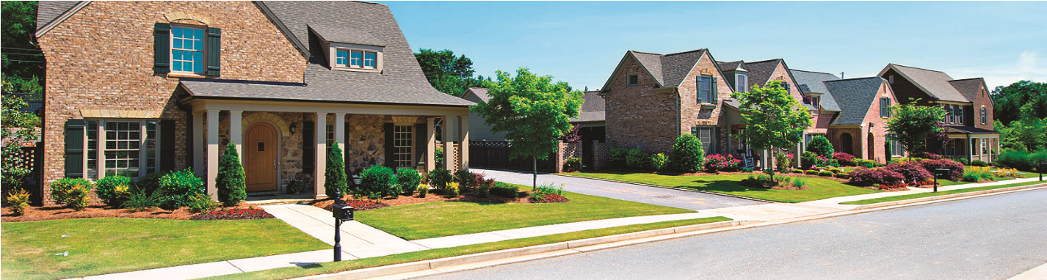
MICHIGAN INSURANCE GROUP
859 SOUTH MAIN ST. • PLYMOUTH, MI 48170 PHONE (734) 459-9797 • Fax (734) 459-8866
SERVING CONDOS IN MI SINCE 1972
INSURING BLUE HERON SINCE 2004
DISCOUNTED AUTO AND
CONDO INSURANCE FOR
COMMUNITY RESIDENTS
DAVID J. MacCARREALL
Commercial Insurance Specialist djmaccarreall@mig-ins.com
JASON MacCARREALL
Multi-Lines Insurance Specialist jasonmacc@mig-ins.com
FAST, FAIR & FRIENDLY SERVICE
KEEPING YOU PROTECTED SINCE 1972

